MESSAGE
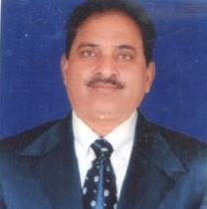
It gives me an immense pleasure to know that Govt. Sen. Sec. School…………………. Distt. Hamirpur (H.P.) is bringing out the……….. edition of the school magazine “………………….” for the session 2021-22.

School Magazine provides the students an appropriate platform to exhibit their talent through writing and also helps in their overall personality development. Publications brought out by the educational institutions provide its students and teachers an appropriate platform to express their feelings in words and fulfill their creative urge. It is also a source of inspiration to others.
I pay my best wishes for publication of “………………….” and also congratulate the principal and the members of the editorial board for their efforts in bringing out this Magazine. The students contributing through their write-ups deserve appreciation for their efforts.
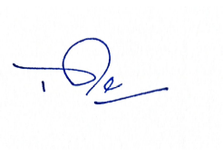 (Bishambher Dass Sharma) Dy. Director of Higher Education,
Hamirpur, Distt. Hamirpur (HP).

